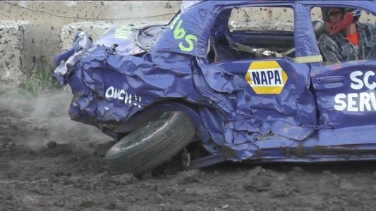 | GRAND MOTOR CRASH, INC.  536 BRIDGE ROAD  CEDARBURG, WI 53012  262-305-6824
OZAUKEE COUNTY FAIR DEMOLITION DERBY
FRIDAY & SATURDAY AUGUST 1ST & 2ND, 2025
LOCATION: OZAUKEE COUNTY FAIRGROUNDS, CEDARBURG
FRIDAY: DEMO STARTS AT 6:30PM (CHECK IN VEH. AT 2PM INFIELD)
SATURDAY: DEMO STARTS AT 6PM (CHECK IN VEH AT 2PM INFIELD)
2025 CHAMPIONSHIP PAYOUTS:
SUPER STOCK *1ST $1,250 - 2ND $750 - 3RD $500
(*IF LESS THAN 15 CARS COMPETING PRIZE MONEY MAY CHANGE)

MIDSIZE/COMPACTS/STOCK 1ST $1,000 - 2ND $750 - 3RD $500
EVENT MAD DOG 1ST $300

STOCK CHAMPIONSHIP –ONLY IF WE RECEIVE 16+ ENTRIES IN THIS CLASS—IF LESS THAN 16 STOCK CARS THIS WILL BE A ONE & DONE HEAT FRIDAY NIGHT.
PAYOUTS FOR 1ST PLACE WILL BE DECIDED AT THAT TIME.

TROPHIES ARE HANDED OUT TRACKSIDE AS WINNERS ARE ANNOUNCED.
PRIZE MONEY IS HANDED OUT SATURDAY EVENING AFTER COMPETITION
COMMENCES. PAYOUTS FOR 1ST PLACE IN THE ONE & DONE HEATS DEPENDS ON
NUMBER OF PARTICIPANTS IN EACH INDIVIDUAL HEAT. THE BIGGER THE HEAT THE BIGGER THE PAYOUT FOR 1ST PLACE.
PLEASE READ RULES THOROUGHLY SO YOU DON’T HAVE PROBLEMS AT CHECK IN
TIME. RULES HAVE BEEN COMPETELY REWRITTEN.
NO ALCOHOL CARRY-INS IN PIT AREA
ALCOHOL IS NOT PERMITTED IN PIT AREA.
CHILDREN 9 AND UNDER WILL NOT BE PERMITTED IN PIT AREA OR CHECK-
IN AREA AT ANYTIME (FAIR BOARD MADE THIS CHANGE DUE TO LIABILITY). ANYONE IN PIT AREA MUST HAVE PIT PASS AFTER 3PM EACH DAY. ANY QUESTIONS, PLEASE CALL JIM AT 262-305-6824 OR 262-377-1955.

